A SMALL BUSINESS NETWORK DESIGN WITH GUEST NETWORK

A PROJECT REPORT

*Submitted by*

## SRIHARI KARTHIK [Reg No: RA1811003010256]

## ROHINI K [Reg No: RA1811003010270]

## MRETUL MADAV [Reg No: RA1811003010278]

## MALLIKA GUPTA [Reg No: RA1811003010296]

*Under the guidance of*

S.Poornima

(Associate Professor, Department of Computer Science& Engineering)

*in partial fulfillment for the award of the degree*

*of*

BACHELOR OF TECHNOLOGY

in

COMPUTER SCIENE & ENGINEERING

Of

FACULTY OF ENGINEERING AND TECHNOLOGY



S.R.M. Nagar, Kattankulathur, Kancheepuram District

**APRIL 2019**

SRMINSTITUTEOFSCIENCEANDTECHNOLOGY

(Under Section 3 of UGC Act, 1956)

**BONAFIDE CERTIFICATE**

Certified that this project report titled “A SMALL BUSINESS NETWROK WITH GUEST NETWORK” is the bonafide work of “SRIHARI KARTHIK [RA1811003010256],ROHINI K [RA1811003010270],MRETUL MADAV [RA1811003010278], MALLIKA GUPTA [RA1811003010296]”, who carried out the project work under my supervision. Certified further, that to the best of my knowledge the work reported herein does not form any other project report or dissertation on the basis of which a degree or award was conferred on an earlier occasion on this or any other candidate.

**SIGNATURE**

S.Poornima

GUIDE

Associate ProfessorDept. of Computer Science& Engineering

Signature of the Internal Examiner.

# ABSTRACT

Small business network is subjected to software and hardware restrictions, repetitive deployments and configurations, and dynamic business requirements. Business network design has a high degree of complexity and security challenges. Building and maintaining a guest wireless network so anybody visiting the company can connect to the internet without interfering with the business wireless network is also essential.

To have guest users on the network, a separate SSID (service set identifier) is to be created. We aim to design a centralized network for the company with a guest network to prevent unauthorized usage by keeping business apps on the business network.

We need to create a separate subnet for guest Network using DNS and a Separate Network for Local Host using FTP. The Guest Network cannot Access certain data within the Small Business Network.

The FTP Server is Used to access Files by the Local Host via a given Username and Password that is not available for the Guest network.

## TABLE OF CONTENTS

**ABSTRACT**

**AKNOWLEGEMENT**

1. CHAPTER 1 1
   1. Introduction
   2. Objective
2. CHAPTER 2
   1. Literature Survey
3. CHAPTER 3
   1. Modules
   2. Network Requirements
   3. Network Integration Plan
   4. Hardware Requirements
   5. Software Requirements
   6. Calculations
4. CHAPTER 4
   1. ARCHITECTURAL DIAGRAM AND DESIGN
   2. IMPLEMENTATION
   3. CONCLUSION

5 REFERENCES

**CHAPTER 1**

**Introduction**

A small Business Network has to be designed for an organization. The organization has occasional guest users with the maximum capacity of 10 users visiting the office. There are total of 70 users in the organization. The major network requirement is to set-up separate subnet for the Guest and LAN network. An FTP server is also available for sharing files. The FTP server is to design in such a way that the office computers should only have the access to share and view files. FTP is nothing but a networking protocol that is based on IP and also on the procedure of copying data through FTP technology, it allows the transference of information between two units that have been connected to the internet. We use two servers, one for local host and the other for guest network. The FTP server is used by the local host in order to deny free access to the guest.

**Objective**

The objective of the project is to design a small business network that can be implemented in an organization easily and conveniently. The network should be cheap and easy to maintain.

**CHAPTER 2**

**Literature Survey**

**(1)**

|  |  |
| --- | --- |
| **Research Article Name** | **Software-Defined LANs for Interconnected Smart Environments** |
| **Problems Addressed/Identified** | With the advancement in technology it is difficult to manage complicated network without having enough knowledge. |
| **Objectives** | To envision a world where networked systems and connected devices are operated at our service, without requiring us to care about what their capabilities are, where they are or how to make them inter-work. |
| **Novelty/Significance** | Create a software which controls and manages elements of a smart environment through their virtual representation. |
| **Limitations/Disadvantage** | It minimizes the surface of attack hence make it vulnerable to poorly secured IOT devices. |
| **Implementation Details/Experimental Setup** | The experimental setup comprises of a software defined LAN (SD-LAN) and a virtualization network |
| **Findings and Conclusions** | A software or a network that works on its own requiring a less maintenance and is inexpensive. |

**(2)**

|  |  |
| --- | --- |
| **Research Article Name** | **Method for supporting guest services provided by a wireless LAN** |
| **Problems Addressed/Identified** | Additional manual intervention from the user of mobile device while setting up the connection with the server. |
| **Objectives** | To establish a relationship between a mobile device and a service, thereby allowing the device to access wireless network as a guest. |
| **Novelty/Significance** | The mobile device is permitted to access the wireless network as a guest without requiring additional manual intervention from the user of mobile device. |
| **Limitations/Disadvantage** | The service denies authorization to the guest network if any one of the rules is violated; in that case it requires manual intervention. |
| **Implementation Details/Experimental Setup** | The experimental setup comprises of a **wireless network**, a **device** enabled to engaged in wireless communication and the **service** coupled to the wireless network via a public network. |
| **Findings and Conclusions** | A method and system for supporting guest services provided by a wireless LAN has been obtained. |

**(3)**

|  |  |
| --- | --- |
| **Research Article Name** | **NetO-App: A Network Orchestration Application for Centralized Network Management in Small Business Networks** |
| **Problems Addressed/Identified** | Integrating SDN and traditional networks is difficult due to the disparities between how they function. |
| **Objectives** | To propose a network architecture that can abstract, orchestrate, and scale configurations based on small business network requirements. |
| **Novelty/Significance** | Network programmability coupled with network automation helps in centralized configuration management of the cloud infrastructure |
| **Limitations/Disadvantage** | No hints of adding a guest network to the system. Because SDN is being focused, adding a guest is much more complex. |
| **Implementation Details/Experimental Setup** | Overlay network consisting of a multi-node OpenStack setup and underlay network is composed of x86 servers running Ubuntu, OpenFlow-capable switches and traditional networking equipment. |
| **Findings and Conclusions** | Aims to create a low-budget optimized network that is platform independent, centrally managed, easy to use, and inexpensive. |

**(4)**

|  |  |
| --- | --- |
| **Research Article Name** | structured network design and implementation for a small office |
| **Problems Addressed/Identified** | multiple design has to be created to be able to view the LAN from a documentation perspective .a successful prototype is created and tested using packet tracer |
| **Objectives** | Calculating the network capacity bandwidth and estimating the number of users . |
| **Novelty/Significance** | Monitor the operation and record changes .This ensures that the system is always fully documented and accountable. |
| **Limitations/Disadvantage** | it has no local servers .The major issue was unavailability of power at the site |
| **Implementation Details/Experimental Setup** | The design was first stimulated using cisco packet tracer and Wireshark protocol analyzer .During implementation there should be strict adherence to standards . |
| **Findings and Conclusions** | The paper outlined the steps involved in structure network design .it presented the steps of a network design and demonstrated a practical implementation using a real life case study |

**CHAPTER 3**

**Modules**

**Network Requirements**

1. 3 Switches
2. 3 Router
3. Coaxial Copper Cable
4. FTP Server
5. 70 devices

**Network Integration Plan**

When building a small office network, the two most essential pieces of equipment you will need are switches and routers. Though they look similar, the two devices perform different functions within a network.

1. Switches

Switch facilitates the sharing of resources by connecting together all the devices, including computers, printers, and servers, in a small network. Thanks to the switch, these connected devices can share information and talk to each other, regardless of where they are in a building or on a campus. Building a small network is not possible without switches to tie devices together.

2. Router

Just as a switch connects multiple devices to create a network, a router connects multiple switches, and their respective networks, to form an even larger network. These networks may be in a single location or across multiple locations. When building a small business network, you will need one or more routers. In addition to connecting multiple networks together, the router also allows networked devices and multiple users to access the Internet.

**Hardware Requirements**

1. Router –A router is a networking device that forwards data packets between computer networks. Routers perform the traffic directing functions on the Internet. Data sent through the internet, such as a web page or email, is in the form of data packets.

2. Switch - A network switch (also called switching hub, bridging hub) is networking hardware that connects devices on a computer network by using packet switching to receive and forward data to the destination device.

3. Coaxial Copper Cable – Coaxial cable, or coax is a type of electrical cable consisting of an inner conductor surrounded by a concentric conducting shield, with the two separated by a dielectric; many coaxial cables also have a protective outer sheath or jacket.

4. Server - A server is a computer or system that provides resources, data, services, or programs to other computers, known as clients, over a network. In theory, whenever computers share resources with client machines, they are considered servers.

5. PC - It includes one or more high resolution displays and a faster processor than a personal computer (PC). A workstation also has greater multitasking capability because of additional random-access memory (RAM), drives and drive capacity. A workstation may also have a higher-speed graphics adapters and more connected peripherals. The term workstation also has been used to reference a PC or mainframe terminal on a local area network (LAN). These workstations may share network resources with one or more large client computers and network servers.

**Software Requirements**

1. CISCO packet tracer Software

**Calculations**

|  |  |
| --- | --- |
| **Cisco RV042 Small Business 10/100 4-Port VPN Router(3pcs)** | Rs.6,253 *3=18759Rs |
| **FTP server** | 7500RS /MONTH |
| **Google Cloud DNS Server** | Free or 600/monthly |
| **Cisco 24 Port Gigabit Switch (10/100/1000)**  **(3 pcs)** | Rs.6600*3=19800Rs |
| **Total Price (approx.)** | Rs.46000 |

**CHAPTER 4**

**Architectural Diagram**

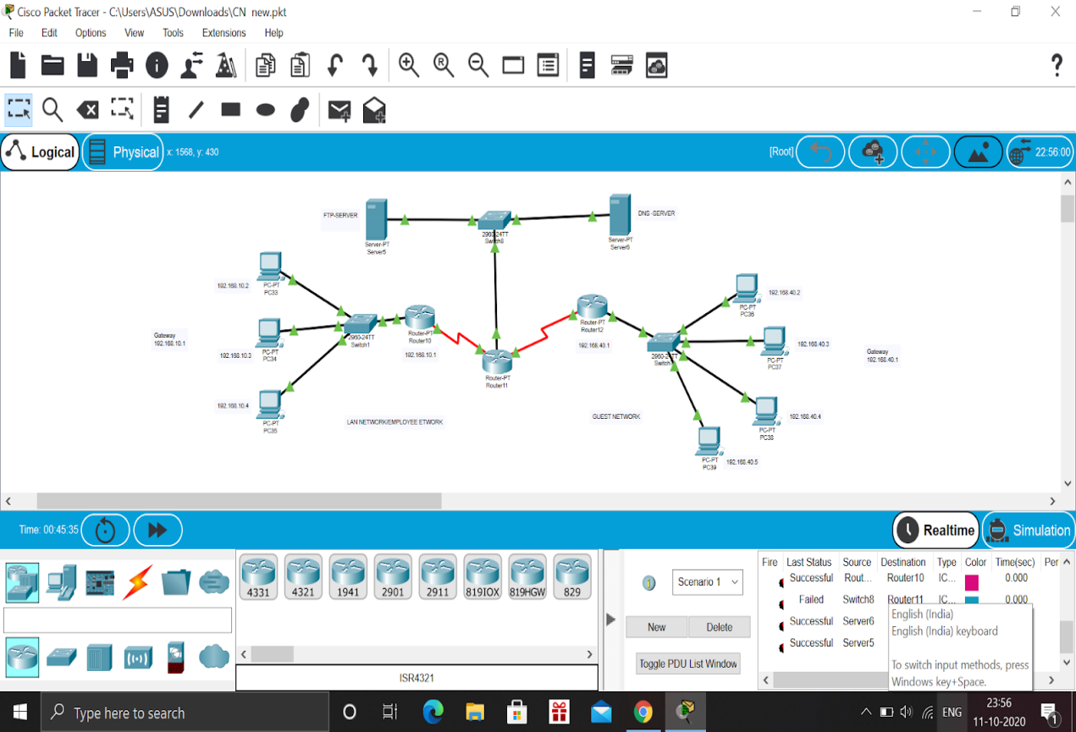

**Small Business network design with guest network**

The given image illustrates the architecture diagram for the **small business network design with guest network**.

In the given architecture, we used PC systems and connected them to two different servers, one is the local host and other is for the guest network. The FTP server is used by the local host in order to deny free access to the guest. The FTP server is to design in such a way that the office computers should only have the access to share and view files.

For the simplicity of depiction, we use 7 user systems instead of 70. We connect 3 PCs to the local host, which have the FTP incorporated, whereas, we connect 4 PCs to the guest network and the users using the guest network cannot access the internal files of the local host.

We have connected the Elements according to the given configuration and will Implement the Small Business Network using FTP server for enabling Local host and Guest Network.

**Implementation**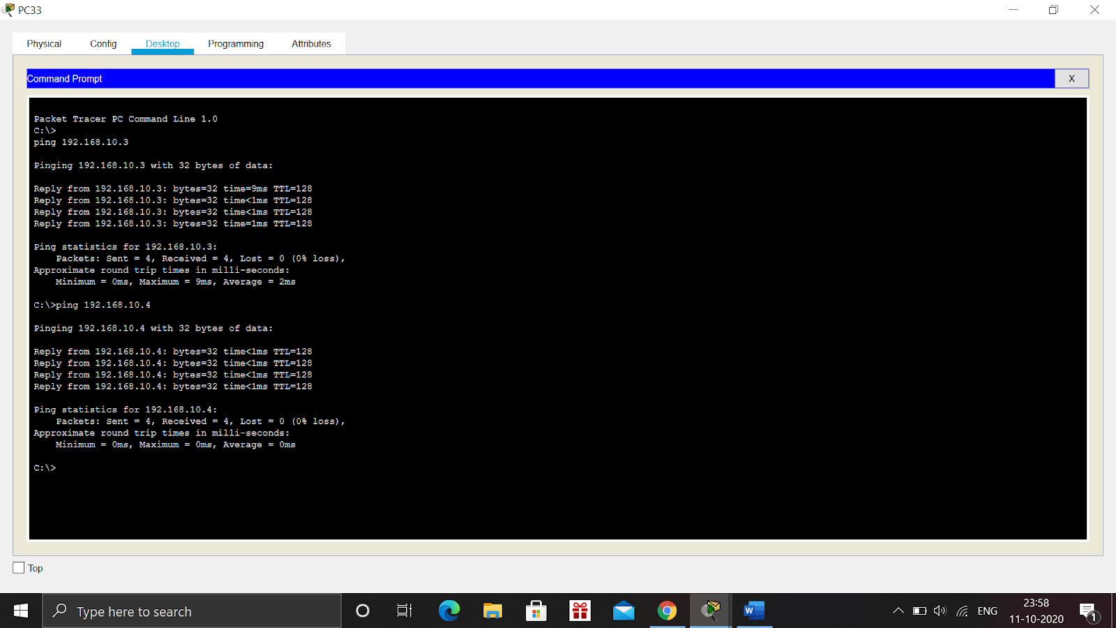

**Illustration of the host connection**

The hosts are connected using the switches and the routers. & PCs systems are segregated and then connected to the local host and guest network respectively. We assign the IP address to the PCs namely, 192.168.10.3 etc. Then, we ping any of the systems using the **ping** command on the command prompt, as **ping 192.168.10.3**

After that, we get the status of packets delivered to the pinged system. If the status displays **Lost=0**, then it displays that all the packets have been successfully delivered and the connection between the hosts has been established.

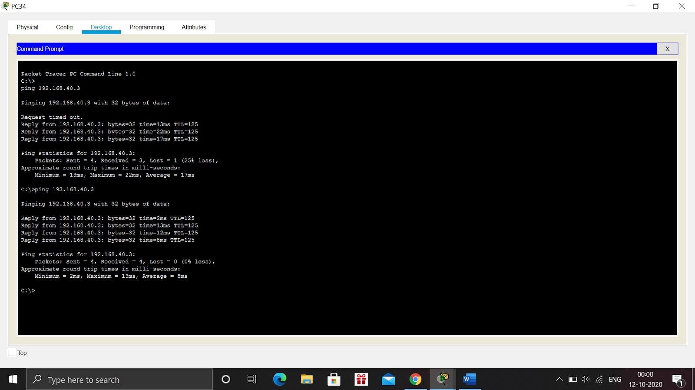

**ILUSTRATION OF THE GUEST CONNECTION.**

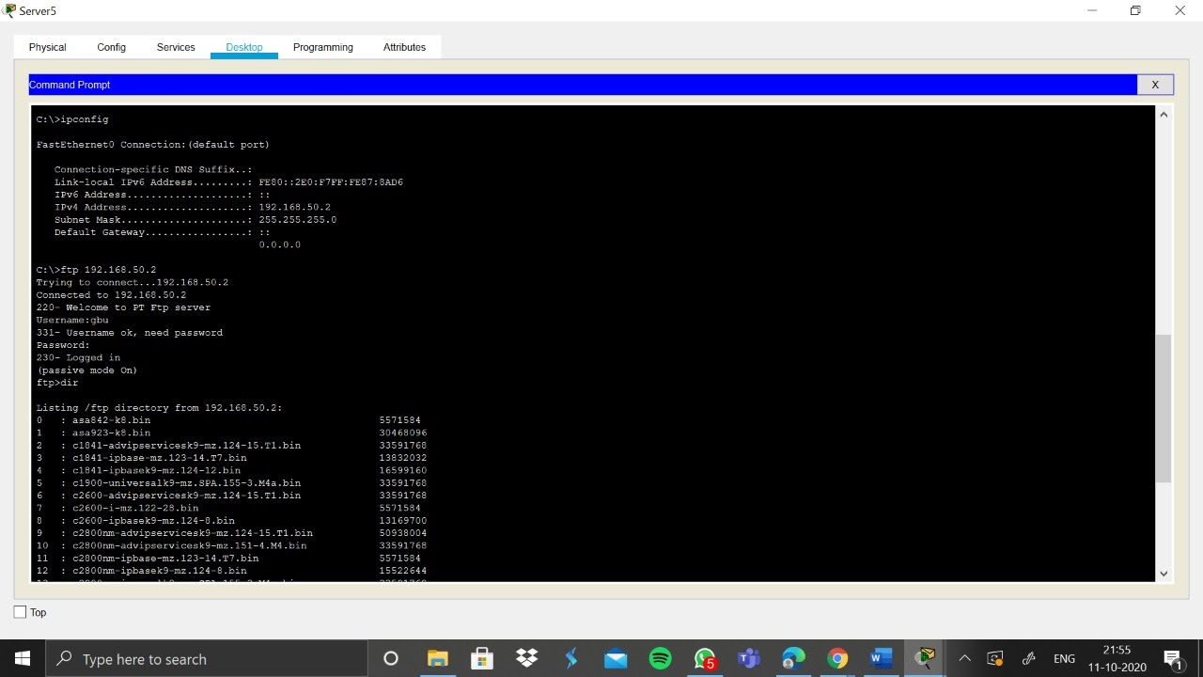

**Illustration of the FTP connection**

We establish the DNS and FTP server on guest network and local host respectively. By using the File Transfer Protocol, we can ensure the security of the internal files and data possessed by the local host, which the guest user cannot access.

To ensure the establishment of the FTP server, input the command **ipconfig** on the command prompt. This will display the status of the established connection. Then, use **ftp 192.168.50.2**to access the ftp server. The server will ask for username and password to ensure the security of the files possessed by local host. Only the systems under local host can access the username and password. Once the username and password is provided, the list of directories of the local host can be accessed by the user.

**FTP**

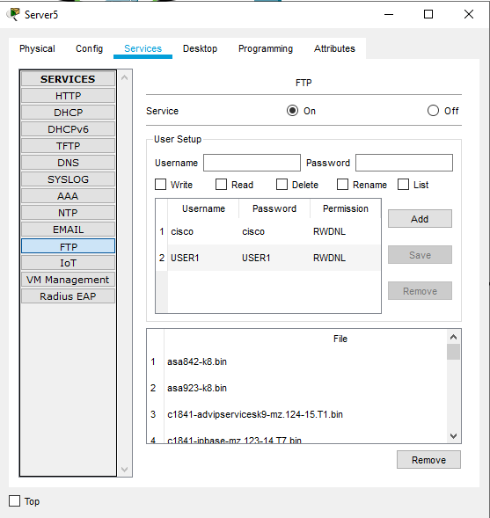

**As we can see in this image, the FTP has been enabled for the Local Host Side. Here the Default Username for the FTP is “cisco” and Default password is “cisco”. We can enter this Username and Password and access the FTP and enable the Local host to access the Files via the FTP.**

**The Guest Network however cannot access all the files present in the Network.**

**We can Add files to the Network via the FTP by the following way-**

* **Create** a file in the Laptop then **upload** it to the server using **FTP**.

To do this, open the **Text Editor** in the Desktop, create a file and give it your name of choice.

Type any text in the editor then **save** your file. e.g. Examplefile.txt.

Now upload the file from the Desktop to the server using FTP.

So to do an FTP upload, we’ll type:

put Examplefile.txt.

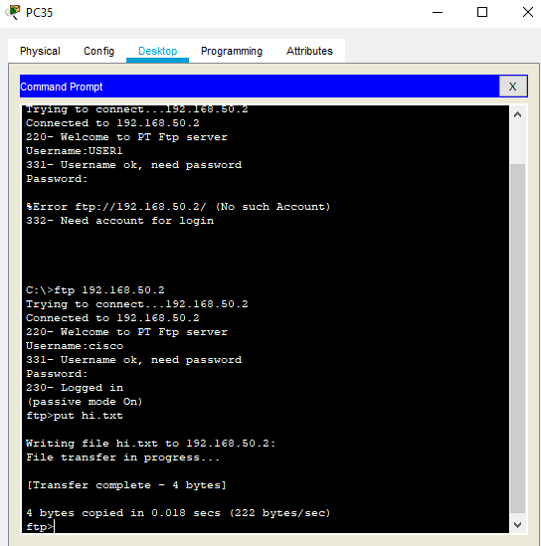

Here we have added a File named “hi”. So we can now check whether the file has been added to the FTP Server in the Network.



We can now confirm the file has been added in the FTP Server

**Conclusion**

Herby, we conclude that the Small Business Network Design with Guest Networkhas been implemented with uninterrupted service and an FTP server. The two servers have been successfully established using FTP and DNS for the local host and the guest network respectively. Hence, the File Transfer Protocol is successfully implemented to ensure the security of the files and directories of the local host and no direct access by guest network can be provided.

**References**

1. <https://patentimages.storage.googleapis.com/25/ae/87/c8e2d62708e6f2/US20060014520A1.pdf>
2. <https://www.researchgate.net/publication/256436789_Structured_Network_Design_and_Implementation_for_a_Small_Office_Home_Office_-_TutorialReport>
3. <https://core.ac.uk/display/160780214?recSetID>=
4. <https://stuffoholics.com/small-business-network-setup-diagram/>
5. <https://www.youtube.com/watch?v=ITsezBQU_Co>